Want to contact me?
Go to
www.MySpamSponge.com
And enter my
blueeyes
handle (contact code)

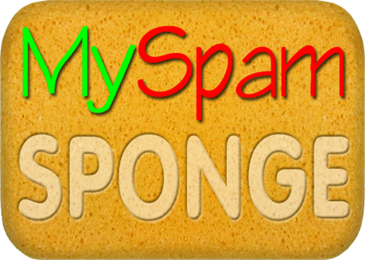

Spam has met its match, but I haven't met mine . . . yet!

